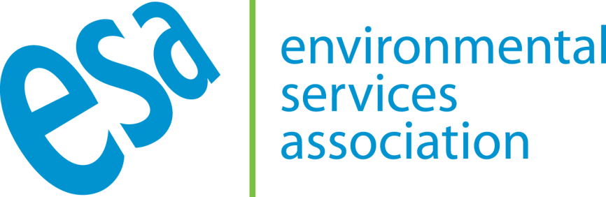

ESA PRESS STATEMENT

Health study should reassure residents living near Energy from Waste plants

LONDON, 21 June 2019: The UK’s waste and recycling sector has today responded to a study from Imperial College London’s Small Area Health Statistics Unit (SAHSU) addressing health impacts of emissions from Energy from Waste (EfW).

The Environmental Services Association (ESA), which represents the sector, has welcomed the clear evidence that there is no link between EfW chimney emissions and the health impacts under investigation, and has called for further work on elements of the paper that were inconclusive.

ESA’s Executive Director, Jacob Hayler said:

“The latest study from SAHSU reflects the research unit’s own earlier findings that there are no conclusive links between exposure to EfW emissions and adverse health impacts. The paper reinforces Public Health England’s position, which remains that modern, well run and regulated municipal waste incinerators do not pose a significant risk to public health, and this should reassure anyone living near an EfW plant.

“We would however welcome further research into some health aspects raised by the report. As recognised by the researchers, other sources of pollution—as well as socio-economic dynamics—may be at play, and we would like to see further work on this subject so that we can reassure everyone that—as per the wealth of existing evidence—EfWs are a safe and clean way of dealing with non-recyclable waste whilst also generating sustainable heat and power for homes and businesses.”

ENDS

Notes to editors:

- The Environmental Services Association (ESA) is the trade association representing the UK’s resource and waste management industry, which is leading the transformation of how the UK’s waste is managed.

- We work with all levels of government, regulators and the public to deliver a more sustainable waste and resource management solution for the UK. ESA’s recent Circular Economy report ‘Going for Growth – A practical route to a circular economy’, which outlines how a Circular rather than a linear economy can help manage resources sustainably, can be downloaded here.

- ESA’s Members manage waste on behalf of the whole of society and we are recovering more than ever before. For example, the industry has helped quintuple the UK’s household recycling rates over the last decade.

- The sector at a glance
- Total turnover: £11 billion
- Direct Employment: 106,000 people (including waste collection, treatment and materials recovery)
- Municipal waste handled each year: 27 million tonnes
- Energy generated (across landfill gas, anaerobic digestion and energy from waste) each year: approximately 11,867 GWh, which is 3.5% of the UK's electricity
    - 9,083 GWh of that was renewable electricity (taking out non-biodegradable portion of EfW) which is 11% of UK’s renewable electricity
- Greenhouse gas emissions down by 70% since 1990.
- The top seven companies account for approximately 40% of turnover. Many hundreds of SMEs provide either localised or more specialised services
- Waste & recycling is the most highly rated of all council services by the public (2016 survey)

For further details please visit www.esauk.org

Press Contact
ESA Press Office - (0207) 824 8882
Email - info@esauk.org / press@esauk.org

