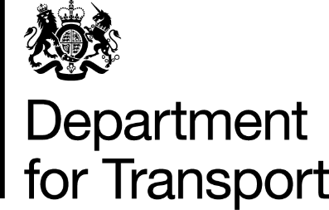

Follow-up form to be sent to Department for Transport no later than one week after the end of the relaxations that began on 9 April 2022 and are due to end on 8 May 2022.

Please return this form by 15 May 2022, ensuring both pages are completed and that you have read and confirmed the declaration.

Please fill out all the fields below and send your completed form by email to FOLRnotification@dft.gov.uk

Name of operator

Contact details of operator (Email/telephone)

Operator Licence Number(s)

Name of responsible transport manager(s)

How many drivers used the relaxations?

Over what date range were the relaxations used from and until?

How many times were the relaxations used in that period (total instances used)?

Were increased daily driving limits used?

Was the reduction of the daily rest requirements used?
Did you make use of the increased weekly and fortnightly driving limits?
Was the option to postpone starting a weekly rest period until after 7 24-hour periods used?

What type of loads were carried?
Please specify how you assessed the risks of using the temporary relaxation and what control measures and/or mitigations were put in place to ensure the safety of the driver, other road users, and others (such as those involved in loading and unloading the vehicle)?

Declaration:
I declare that the relaxations were only used on the basis that all three of the following conditions on the use were met:
- Evidence of detriment to wider community - That there is a significant risk of a threat to human and/or animal welfare or a failure of a particular supply chain that will have a serious impact on essential public services;
- There must be evidence that a relaxation would lead to a significant improvement in the situation; and
- Driver safety must not be compromised. Operators and self-employed drivers must assess the risks of using the temporary relaxation and implement suitable control measures and/or mitigation so that the safety of the driver, other road users, and those involved in loading and unloading is not compromised.
Tick to confirm your declaration: □

Failure to comply with the above, would be an indication to enforcement authorities that
the relaxations may have been used inappropriately and follow-up investigatory action
could occur.

