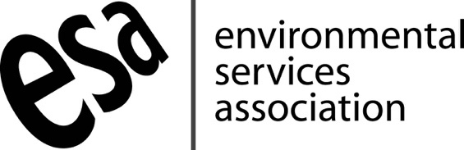

Statement issued on behalf of the Environmental Services Association (ESA)
Thursday 8th September 2022
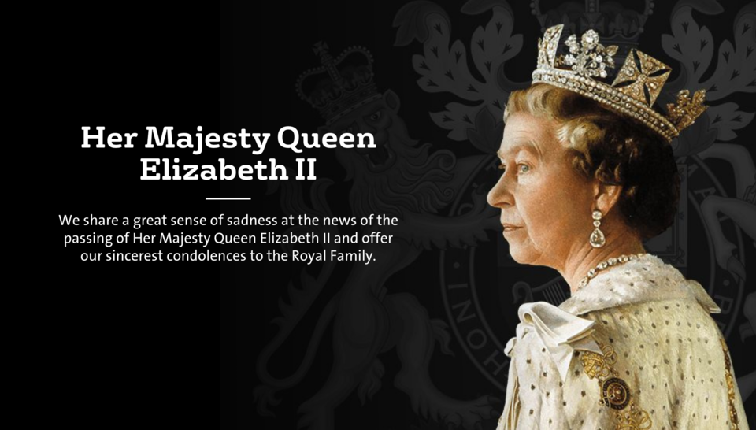

“The Environmental Services Association, our members and the wider resources and waste management sector in the UK are deeply saddened by the death of our longest-serving monarch, Her Majesty the Queen.

We share a great sense of sadness at the news of the passing of Her Majesty Queen Elizabeth II and offer our sincerest condolences to the Royal Family, which has long shown its support for our sector.

Her Majesty’s life-long commitment to public service and her devotion to duty set a high standard for everyone involved in the provision of public services in the United Kingdom and her memory will endure in the resources and waste management sector’s continued admiration and pursuit of this high benchmark.”

Media contact
ESA Press Office: 020 7591 3214
Email: b-johnson@esauk.org

